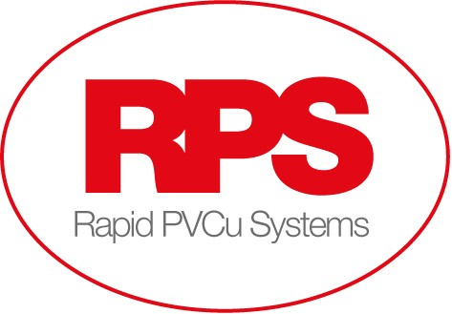

Rapid PVCu Systems are looking for experienced Window Fitters to join our team.
We are based in Harworth, Doncaster, and manufacture and supply windows and doors to customers throughout the Yorkshire, Nottinghamshire, and Midlands areas.

The role:
To fit double glazed windows and doors and various properties to a high standard.
Using our Harworth site as a base, travelling to sites daily.
Working hours are Monday to Friday

The ideal candidate:
Previous experience in this type of role
Good Customer Service skills
Attention to detail
Reliable and flexible
CSCS Card would be an advantage, but not essential as we are happy to provide the training
Full UK driving license desirable

We provide:
Excellent salary, average £40,000 - £50,000 per annum
Overtime
Company Van & Fuel Card
Permanent employment, long term
Bonus Scheme

If you are interested and would like to know more, please send an up to date cv to careers@rapidpvcusystems.co.uk

