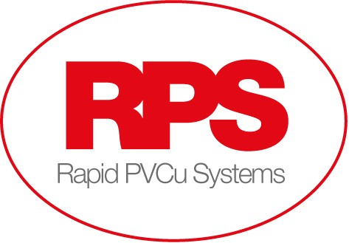

Rapid PVCu Systems are looking for experienced Production operatives to join our team.
We are based in Harworth, Doncaster, and manufacture and supply windows and doors to customers throughout the Yorkshire, Nottinghamshire and Midlands areas.
Ideally we are looking for candidates that have worked within Window Fabrication, Assembly, Glazing.

Shift available:
Days: Monday to Friday 06.00 – 14.30

Hourly rate:
Days: From £10.00 per hour plus £25p per hour attendance bonus offered
Overtime is available which is paid at time and a half.

The role:
Working within a Manufacturing environment, you will assist with the production of UPVC products, including windows and doors.
Some of the tasks will involve heavy lifting.
This is an active role, involving standing, and manual handling activities throughout the full shift.
You will join one of our existing teams in one of the below areas:
- Glazing
- Window Fabrication
- Window Assembly
- Doors
- Goods in / Out

The ideal candidate:
Ideally we are looking for candidates that have worked within Window Fabrication, Assembly, Glazing.
Experience using power tools / hand tools would be desirable, but not essential. Full training will be provided.
Good time keeping and attendance.
Able to follow company Health and Safety policies.
Good understanding of written and spoken English.

We provide:
Salary from £10.00 per hour, depending on experience.
Generous holidays of up to 24 days plus Bank Holidays per year
Attendance bonus of £0.25p per hour worked (if achieved)
Fixed day shift Monday to Friday
Permanent Employment
Regular overtime available
Career progression
Company pension scheme

If you are interested and would like to know more, please send an up to date cv to careers@rapidpvcusystems.co.uk

