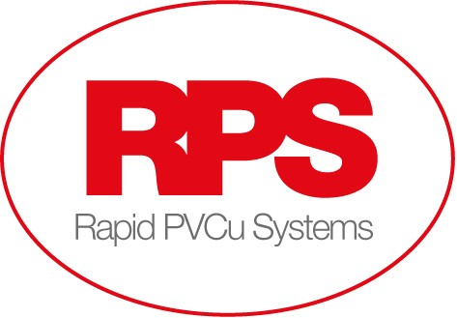

Rapid PVCu Systems are looking for an experienced Service Engineer to join our team.
We are based in Harworth, Doncaster, and manufacture and supply windows and doors to customers throughout the Yorkshire, Nottinghamshire and Midlands areas.

The role:
Undertaking remedial works.
Dealing with warranties on occupied properties daily.
Using our Harworth site as a base, travelling to properties.
Working hours are Monday to Friday

The ideal candidate:
Previous experience in this type of role
Good Customer Care skills – you will be dealing with customers on a regular basis
Attention to detail
Reliable and flexible
Full UK driving license desirable

We provide:
Excellent salary, Negotiable depending on experience £27,000 - £29,000 per annum
Overtime
Company Van & Fuel Card
Permanent employment, long term

If you are interested and would like to know more, please send an up to date cv to careers@rapidpvcusystems.co.uk

